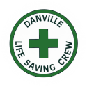
Position Announcement

DATC / DLSC
Emergency Medical Technician - Intermediate

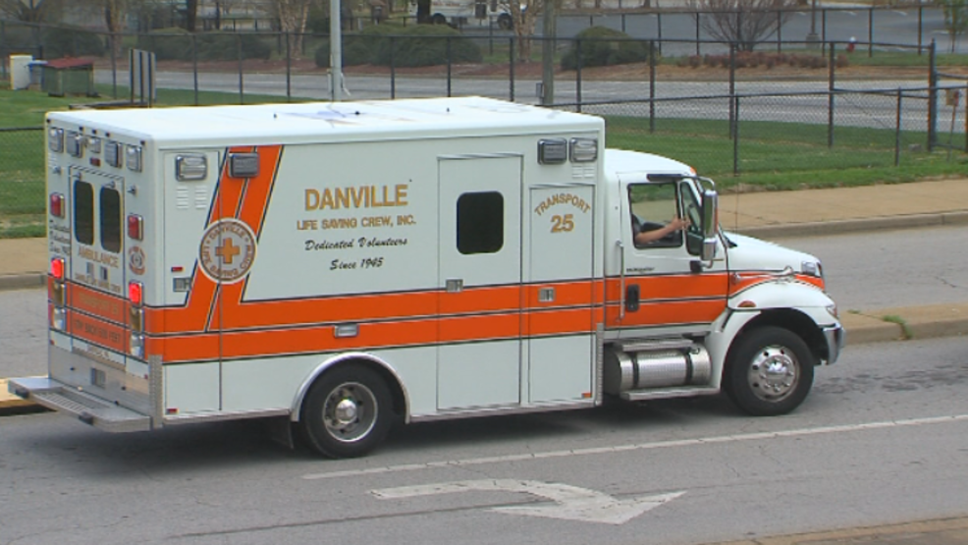
Danville Life Saving Crew is seeking candidates for its EMT – Advanced responder. An EMT–Intermediate provides basic emergency treatment for respiratory, trauma and cardiac emergencies, as well as obstructed airways, and are trained to administer some medications, as well as intravenous fluids. The EMT-I always works in collaboration with and under the direction of other crew members and the incident command. The EMT-Intermediate will:

- Assume responsibility for advanced life support pre-hospital patient care; including supervision and care of patients utilizing advanced clinical skills and tools such as sphygmomanometers, stethoscopes, monitors, defibrillators, IV therapy, endotracheal intubation, numerous medications, and other associated tasks in accordance with medical protocol.
- Perform independently in situations involving basic life support activities.
- Direct others, while rendering patient care, including but not limited to EMRs and EMTs.
- Work seamlessly with both career and volunteer personnel.
- Safely operate emergency ambulances, crash trucks, and other response vehicles in emergency response situations.
- Follow all protocols of the Western VA EMS Council.
- Provide training to basic life support personnel, EMRs and EMTs in training.
- Assume initial command of scenes involving multiple patients and/or complex incidents.
- Attend training classes and perform CBS (Competency Based Skills) to demonstrate proficiency in required skills per the Western VA EMS Council Protocols.
- Daily assignments shall be based on call volume and may be changed without prior notice being given.
- Adhere to all other agency policies, procedures, and SOGs found in the bylaws or Personnel Handbook.

Performance Standards
- Maintain safe control of rescue scenes; fulfil the role of attendant-in-charge on advanced life support incidents; accurately and effectively determine the nature and extent of illness or injury to a patient.
- Administer medical treatment to and transport sick and injured patients to the appropriate medical facility.
- Direct supporting personnel as required.
Effectively communicate with patients, bystanders, members of the emergency health care team, and media as necessary.
- Safely operate emergency vehicles; perform basic maintenance of equipment.
- Participate in and contribute to training drills.
- Interact professionally with career and volunteer emergency services personnel.
- Maintain appearance in accordance with agency guidelines.
- Discharge all duties according to agency SOGs, policies, procedures, WV EMS protocols, and OMD standing orders.
- Demonstrate the ability to work under high stress conditions.
- Implement incident command and direct the activities of all personnel on scene in the absence of a formal supervisor or officer.

Eligible candidates must:
- Be at least 18 years of age to function as attendant-in-charge in Virginia.
- Successfully complete FEMA training including NIMS 100, 200, 700, 800.
- Complete a VAOEMS approved Emergency Vehicle Operator’s Course (EVOC).
- Successfully complete required drug screening.
- Have a valid, state issued driver’s license.
- Pass required VAOEMS background check, including fingerprint submission.
- Be available evenings, weekends, holidays, and extra hours as operational needs dictate.
- Must be able to work in inclement weather (i.e. snow, sleet, rain, thunderstorms, etc.).
- Wear PPE such as safety vest, eye protection, gloves, and other designated attire and equipment in designated areas of risk.
Candidates will be challenged to continuously expand:
- Knowledge of
  - Company’s Personnel Handbook.
  - HIPAA rules and regulations.
  - The City’s roads and traffic patterns.
  - EMS laws, regulations, and ordinances.
  - Local EMS protocol.
  - EMS principles and techniques.
- Skills
  - Performing duties required of a State of Virginia certified Emergency Medical Technician.
  - The use of tools and adjuncts associated with pre-hospital basic life support patient care.
  - Skill in operating Class 1,2, and 3 vehicles in emergency conditions
  - The preparation of computer-based reports and forms.
  - Dealing with people of various culture and ethnicities in a variety of situations.
  - Working side-by-side with both career and volunteer emergency personnel.
  - Managing emergency medical incident scenes.
  - Making appropriate and timely patient care decisions within the scope of local protocols and medical control guidelines.
- Abilities to
  - Work, unsupervised, in high stress situations including but not limited to functioning as the Attendant in Charge (AIC) over patient care in Life Threatening Emergencies, Emergency Vehicle Operations in high volume traffic, and extreme weather conditions.
  - Follow verbal and written orders.
  - Direct subordinates.
  - Maintain EMT and CPR certifications.
  - Teach and/or participate in training drills.
  - Function in any other capacity as necessitated and within legal parameters dictated by the needs of the business or the current EMS call.
  - Lift 50 pounds unassisted.
Hours of Service
- 40-hour work week with hours varying within the 24-hour shift day based on operational needs.
- Must be able to work in inclement weather (i.e. snow, sleet, rain, thunderstorms, etc.).
Compensation:
- Hourly wage position ranging between $16 and $20 per hour
- Health insurance & 401K Retirement

To Apply:
Visit dlsc.org/application.

The Danville Life Saving Crew is a 501(c)3 organization with a team of over 140 professionals serving the Danville, Virginia, region. Our mission is to be the leader in providing pre-hospital care to the sick and injured.

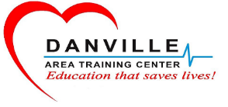
The Danville Area Training Center is a 501(c)3 organization serving the Danville, Virginia, region. Our mission is to provide superior training to our members and members of other agencies throughout the community, while providing opportunity for personal growth, career development and advancement for those who work in the EMS field. Our organization directly supports the Danville Life Saving Crew in its mission to be the leader in providing pre-hospital care to the sick and injured.

